Open Data Governance Template

Recommended Components

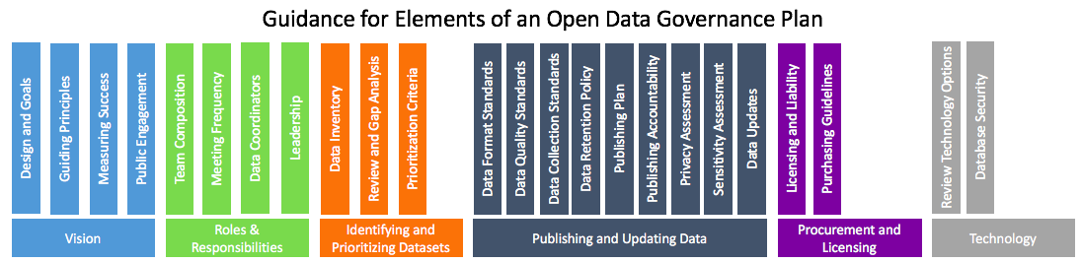

**Vision** **3**

Guiding Principles 3

Design and Goals 3

Measuring Success 3

**Roles and Responsibilities** **3**

Team Composition 3

Leadership 3

Department Coordinators 3

Open Data Team? 3

Advisory Board? 3

Responsibilities and Decision Making 3

Meeting Frequency 3

Accountability and Reporting 3

**Identifying and Prioritizing Datasets** **3**

Data Inventory 3

Review and Gap Analysis 3

Prioritization Criteria 3

**Publishing and Updating Data** **4**

Data Format Standards 4

Data Quality Standards 4

Data Retention Policy 4

Publishing Plan 4

Publishing Accountability 4

Privacy Assessment 4

Data Publishing Workflow 4

Data Updates Workflow 4

Data Improvements Workflow 4

**Data Collection Standards** **4**

Procurement and Licensing 4

Purchasing Guidelines 4

**Appendix: Open Data (retrospective v prospective data), Rebecca working notes** **4**

**Appendix: Technology** **5**

**Appendix: Decision Point Considerations** **5**

# Vision

## Guiding Principles

## Design and Goals

## Measuring Success

# Roles and Responsibilities

## Team Composition

## Responsibilities and Decision Making

## Meeting Frequency

## Accountability and Reporting

# Identifying and Prioritizing Datasets

## Data Inventory

## Review and Gap Analysis

## Prioritization Criteria

# Publishing and Updating Data

## Data Format Standards

## Data Quality Standards

## Data Retention Policy

## Publishing Plan

## Publishing Accountability

## Privacy Assessment

## Data Publishing Workflow

## Data Updates Workflow

## Data Improvements Workflow

# Data Collection Standards

## Procurement and Licensing

## Purchasing Guidelines

# Appendix: Decision Point Considerations

**Decision point: Data governance team composition**

*List who will be on the initial “open data leadership team” and then who you expect to invite to be on a more permanent “open data governance committee.”*

1. Pre-launch (internal):
   1. Committee Chair
   2. Mayor/City Manager/other executive
   3. Project Lead
   4. Departments, which may include: fire, police, code enforcement, public safety, health & human services, 311, planning & zoning, public works, parks, etc.
   5. Others

II. Post-launch/ongoing (may include external)/additional stakeholders:

1. Those listed above
2. IT
3. Local universities
4. Communications department(s)
5. Others

**Decision point: Meeting frequency**

*Note how often the governance committee will meet to discuss the open data program. This may change - you could discuss this as the first meeting and get feedback.*

**Decision point: Data governance team responsibilities**

*Add to or expand on items below.*

1. Short-term:
2. Review and edit draft policy
3. Gain policy buy-in
4. Develop strategy to prioritize internal datasets to release
5. Review accessibility of data
6. Review quality of data
7. Develop workflow to review datasets as they are released
8. Develop strategy to identify demand for datasets from external stakeholders
9. Review technology options

II. Long-term

1. Establish policies for data quality, user requirements, [privacy concerns](http://www.seattle.gov/tech/initiatives/privacy)
2. Automate datasets
3. Other

**Decision point: Public engagement**

*Document plans for engaging the public in open data program development.*

* 1. Pre-launch
  2. Post-launch

**Decision point: Tracking progress and demonstrating value**

*Brainstorm items that you will track to demonstrate progress on or value of the program. Examples are below:*

* # of departments that have completed the dataset inventory (%)
* # of departments that have completed publishing plans (%)
* Percent of inventoried datasets that are published
* Percent of datasets updated on time
* Percent of datasets with required metadata
* Percent of respondents indicating that they use the data portal to access data internally and from other departments
* Number of products made with open data
* Percent of users that are return users
* Number of dataset downloads
* Number of data portal accounts
* Number of API hits
* Number of city responses to open data suggestions
* Open data presence on social media
* Number of participants at a open data community event (hackathon, strategic plan visioning, data release party, etc.)
* Number of ad hoc data requests
* Number of FOIA requests
* Number of internal or intra-departmental data requests
* Number of staff hours responding to data requests

# Separating this out into manual v. plan

Outlines to review:

*Plan*

1. *Vision*
   1. *Guiding Principles*
   2. *Design and Goals*
   3. *Measuring Success*
2. *Prioritizing Datasets*
   1. *Data Inventory Review and Gap Analysis*
   2. *Prioritization Criteria*
   3. *Publishing Plan*
3. *Performance/Annual Report*

*Manual*

1. *Roles and Responsibilities*
   1. *Team Composition*
      1. *Leadership*
      2. *Department Coordinators*
      3. *Open Data Team*
      4. *Advisory Board*
   2. *Responsibilities and Decision Making*
   3. *Meeting Frequency*
   4. *Accountability and Reporting*
2. *Identifying Datasets*
   1. *Data Inventory Gap Analysis*
   2. *Annual Data Inventory*
3. *Publishing and Updating Data*
   1. *Data Format Standards*
   2. *Data Quality Standards*
   3. *Data Licensing Standards*
   4. *Data Retention Policy*
   5. *Publishing Accountability*
   6. *Privacy Assessment*
   7. *Data Collection Standards*

*Appendix: Data Publishing Workflow*

*Appendix: Data Updates/Improvements Workflow*